

**OnFest**

**Project Plan v2**

Date: 25 Februari 2018

Course: ProP

Group: 31

Dimitar Parpulov - 3207358

Diqin Yang - 3324087

Dongdong Ke - 3338207

Phat Tran - 3335968

**Table of Contents**

1. ***Chapter 1***
   1. Project Statement
   2. Formal Client
   3. Project Leader
   4. Current Situation
   5. Problem Description
   6. Project Goal
   7. Project Deliverables and Non-Deliverables
   8. Project Constraints
   9. Project Risks
2. ***Chapter 2***
   1. [Project Phasing](https://docs.google.com/document/d/1MTbcWzN2N5sH5wan6hqOxl8rTX1kvQTQIBtjn1HV81A/edit#heading=h.tp9znly8nmzw)
   2. Phase 1: Initiation
   3. Phase 2: Design
   4. Phase 3: Building and developing
   5. Phase 4: Testing
   6. Phase 5: Finalizing

# **Revision History**

|  |  |  |  |
| --- | --- | --- | --- |
| Version | Date | Summary of changes | Revision |
| 1 | 25-02-2018 | Added all sections, cover of the document, filling the information for each section; |  |
| 2 | 02-03-2018 | Added more risks, constraints, more specific phasing |  |
| 3 | 03-18-2018 | Added color and fixed some mistakes |  |
| 4 | 03-26-2018 | Filled up Changes section |  |

# 

# **Project Statement**

In this document, we will describe why our project is initiated and what we will accomplish. The following topics will be described: the client, the project leader, the initial situation, the problem description, our project goal, the deliverables and non-deliverables, the constraints and the risks.

# **Formal Client**

Mister Mikaeil of the ICT Department from Fontys University in Eindhoven is the project client.

Contact information

Mr. Mikaeil

R1 Room 2.39, Eindhoven

[m.shagelanilor@fontys.nl](mailto:m.shagelanilor@fontys.nl)

Working hours: Monday - Friday (Weekdays) 8:00AM to 6:00 PM

# **Project Leader**

Mr. Dimitar Parpulov of the ICT Department from Fontys University in Eindhoven is the project leader.

Contact information

Mr. Dimitar Parpulov

Rachelsmolen 1, Eindhoven

[d.parpulov@student.fontys.nl](mailto:d.parpulov@student.fontys.nl)

Working hours: Monday – Friday (Weekdays) 8:00 AM to 6:00 PM

# **Current Situation**

Our client is from a commercial company specialized in organizing events. Their events have started to attract more visitors, so it has become harder to manage them and now he is looking for somebody to create the software solution for this problem.

# **Problem Description**

A music festival is being organised by our client. We will deliver the software that will allow users to buy tickets, rent a camping spot, deposit money, buy and rent stuff during the event. We will research the most efficient way to create the website and the apps so we can deliver the best possible product to our client. Everything will be user friendly to maximize usability.

# **Project Goal**

The goal of this project is to create a website and a couple of applications. The website will be used to advertise, give info, sell tickets and reserve camping spots for a music festival that our client organises. People who buy tickets to the event will have a personal account on which they can deposit money. This account will be used to check in and out, buy and loan things at the event. A couple of applications and a database are also required in order for the event to go smoothly. We need to create applications for the entry/exit of the festival and camping spot, for the food/drinks/loaning stands and for keeping track of what is happening at the event(how many people are currently in, which stand makes most money, what products are being sold most etc.). The database and 1 of the apps will be used to keep track of what is left in stock and restock when a delivery is made.

# **Project Deliverables and Non-Deliverables**

**In this project the deliverables are:**

* Agenda and minutes of every meeting
* A name (and a logo)
* A setup document
* A website that informs people and allows booking of tickets and reservation of camping spots, include website wireframe
* A database design that supports all applications, include ERD and database design
* A process report
* Applications:
  + Entry to the festival
  + Exit from the festival
  + Entry to the campsite
  + Exit from the campsite
  + Food/drinks shops
  + Loaning stands
  + Overview for the festival
* A presentation about the project

**We will not deliver:**

* Technical and model designs
* Applications source code

# 

# **Project Constraints**

**Constraint 1:** **Time**

The first version of the project needs to be done before 25th of Feb.

The second version of the project needs to be done before 4th of Mar.

The whole project of the block1 should be finished before 6th of April.

The entire project has to be finished by 22th of June.

**Constraint 2:** **Language**

The OnFest event is not only for the Dutch people but is international, so we should use English as the main language for the whole project.(Such as the GUI of the application, the website and the tickets)

**Constraint 3: Ticket**

The tickets should be the identification of each person, we would like to be able to check if someone has purchased a ticket or not and the company hopes that we only can use the identification to buy food and drinks in the event.

**Constraint 4: Quality**

The quality of the prototypes should be as high as possible. This means that the team should only implement fully functional and likeable design.

**Constraint 5:** **Programming**

All the apps should be done on C#.

# 

# **Project Risks**

**Risk 1**: Team members do not participate in meetings or do not voice their opinions.

Ø Probability: **Low**

Ø Influence on project: **High**

- We will lose their ideas and the work becomes harder

Ø Methods to prevent:

- Vote a team leader and the leader can collect the ideas of the teammates before each meeting.

- Teammates try to encourage each other to communicate.

Ø Clean up action: Make a rule about communication.

**Risk 2:** The cost of project is overloading the budget.

Ø Probability: **Low**

Ø Influence：**Low**

- The team will have more works to reduce the cost.

Ø Methods to prevent:

- Make a priority list of every cost.

Ø Clean up action:

- Make the budget higher.

**Risk 3:** Team can’t get enough resources for the project.

Ø Probability: **Low**

Ø Influence: **Medium**

- The team will get low effectiveness

Ø Methods to prevent:

- Maximize the use of limited resources

Ø Clean up action: Find more resources.

**Risk 4:** Programming is time consuming

Ø Probability: **Medium**

Ø Influence: **High**

- The software might not work as intended

Ø Methods to prevent:

- Divide work properly and debug extensively

Ø Clean up action: Test until everything works as intended

**Risk 5:** Website crashing

Ø Probability: **Low**

Ø Influence: **High**

- The website might crash due to overload or unstable server

Ø Methods to prevent:

- Use stable servers that are able to withstand a lot of traffic

**Risk 6:** Data leaks

Ø Probability: **Low**

Ø Influence: **High**

Ø Methods to prevent:

- Limit the people that have access to the data

**Risk 7:** Changes to the designs

Ø Probability: **High**

Ø Influence: **Medium**

* It takes time to make changes to the design and functionality

Ø Methods to prevent:

- More frequent communication

# **Changes**

**Website changes:**

We changed the design of the website compared to the first wireframes we created because of the feedback we received from Mr. Mikaeil. He prefers as less scrolling as possible and as much information with minimal clicks of the mouse. We created 1 page for the Registration and login and users can change their option with just 1 click. We decided to make the depositing of money into users accounts really easy and without redirection to a different page. When users are in their account info they just click a button and a pop-up appears where they can see their current balance and they can deposit or withdraw their money.

**GUI’s changes:**

We changed the GUI’s option for the employees to log in via username and password because they are also going to be given an RFID bracelet which they can use for this purpose. Also each employee will not change his/hers working place so there is no need to make an application to choose where the employee is. This information will be stored into their RFID’s.

# 

# 

# **Project Phasing**

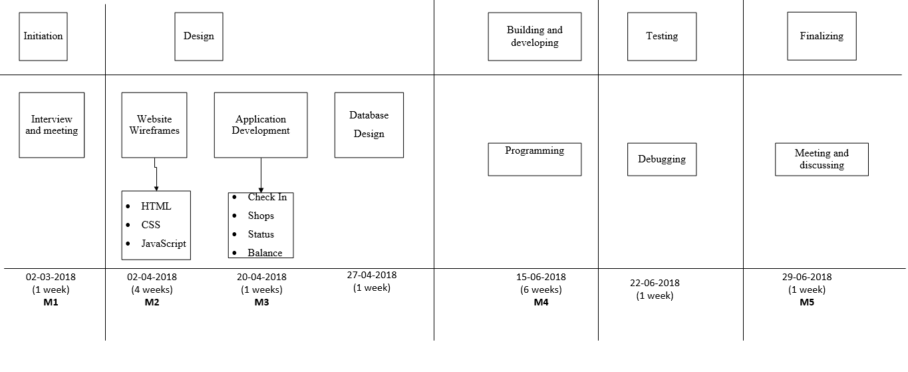

Figure 1 The Main Activities

## **Phase 1: Initiation**

Activity: Interviews and meetings

1. Interviews and meetings with the client and mentor
2. Determine the topic of event
3. Create a logo and name of the company and the festival
4. Assign a position for each team member
5. Group meetings to clarify the project’s problems and goals
6. Manage a schedule for the meetings

**Estimated duration is from 05-02-2018 until 12-02-2018**

## **Phase 2: Design**

Activity: Application GUI, website wireframes and database design

* Make non-functional application GUI
  1. Check in and out for festival and campsite
  2. Shops and loaning stands
  3. Check the overview status of event
  4. Change balance of the visitors based on log files
* Design website wireframe
  1. HTML
  2. CSS
  3. JavaScript
* Database design (ERD)

Deliverables for milestone **M1** are:

* Non-functional applications GUI
* Website wireframe and static part
* ERD(Entity Relationship Diagram)
* Project plan
* Setup document

**Estimated duration is from 13-02-2018 until 3-04-2018**

## **Phase 3: Building and developing**

Activity: Programming

1. Add functionalities to the applications
2. Add functionalities to the website

Activity: database design

1. Create the database
2. Fill the database

Deliverables for milestone **M2** are:

* Versions of the applications with functionalities
* Version of the website with functionalities
* Process report

**Estimated duration is from 4-04-2018 until 20-05-2018**

## **Phase 4: Testing**

Activity: Debugging

1. Find possible bugs
2. Fix the bugs

Deliverables for milestone **M3** are:

* Prototype of application
* Updated report regarding the system stability

**Estimated duration is from 21-05-2018 until 29-05-2018**

## **Phase 5: Finalizing**

Activity: Wrap up

1. Test the application in working environment
2. Meeting with the client and discuss if he is satisfied with the products

Deliverables for milestone **M4** are:

* The finished applications and website

**Estimated duration is from 01-06-2018 until 10-06-2018**